**Week 6 - React SupersetId-6431499**

**Name : Balaji V**

**Exercise 1: Create a new React Application**

**Code:**

**App.js:**

import './App.css';

function App() {

return (

<div className="App">

<header className="App-header">

<div className="welcome-container">

<div className="gradient-text"><h1>Welcome to Cognizant - Balaji - 6431499</h1></div>

<div className="subtitle"><p>My Journey into React development starts here!</p></div>

<div className="features">

<div className="feature-card">

<h3>Fast</h3>

<p>Lightning-fast development</p>

</div>

<div className="feature-card">

<h3>Modern</h3>

<p>Latest React features</p>

</div>

<div className="feature-card">

<h3>Beautiful</h3>

<p>Stunning user interfaces</p>

</div>

</div>

<button className="cta-button">Start Learning React</button>

</div>

</header>

</div>

);

}

export default App;

**App.css:**

@import url('https://fonts.googleapis.com/css2?family=Roboto+Slab:wght@300;400;500;600;700&display=swap');

.App{

text-align: center;

min-height: 100vh;

background: linear-gradient(135deg, #1e3a8a 0%, #3730a3 50%, #ffffff 100%);

display: flex;

align-items: center;

justify-content: center;

font-family: 'Roboto Slab', serif;

}

.App-header{

padding: 40px;

color: #1e3a8a;

max-width: 1200px;

width: 100%;

font-family: 'Roboto Slab', serif;

}

.welcome-container{

background: rgba(255, 255, 255, 0.95);

backdrop-filter: blur(10px);

border-radius: 20px;

padding: 60px 40px;

box-shadow: 0 8px 32px rgba(30, 58, 138, 0.3);

border: 2px solid rgba(30, 58, 138, 0.2);

animation: fadeInUp 1s ease-out;

}

.gradient-text h1{

font-size: 3.5rem;

font-weight: 700;

margin: 0 0 20px 0;

background: linear-gradient(45deg, #1e3a8a, #3730a3);

-webkit-background-clip: text;

-webkit-text-fill-color: transparent;

background-clip: text;

text-shadow: 2px 2px 4px rgba(30, 58, 138, 0.2);

animation: pulse 2s infinite;

font-family: 'Roboto Slab', serif;

letter-spacing: -1px;

}

.subtitle p{

font-size: 1.4rem;

margin: 0 0 40px 0;

opacity: 0.8;

font-weight: 400;

color: #1e3a8a;

font-family: 'Roboto Slab', serif;

}

.features {

display: grid;

grid-template-columns: repeat(auto-fit, minmax(250px, 1fr));

gap: 30px;

margin: 40px 0;

}

.feature-card{

background: rgba(30, 58, 138, 0.1);

padding: 30px 20px;

border-radius: 15px;

border: 2px solid rgba(30, 58, 138, 0.2);

transition: all 0.3s ease;

cursor: pointer;

}

.feature-card:hover{

transform: translateY(-10px);

background: rgba(30, 58, 138, 0.2);

box-shadow: 0 15px 35px rgba(30, 58, 138, 0.3);

border-color: #1e3a8a;

}

.feature-card h3{

font-size: 1.8rem;

margin: 0 0 15px 0;

color: #1e3a8a;

font-weight: 600;

font-family: 'Roboto Slab', serif;

}

.feature-card p{

margin: 0;

opacity: 0.8;

font-size: 1.1rem;

color: #3730a3;

font-family: 'Roboto Slab', serif;

font-weight: 400;

}

.cta-button {

background: linear-gradient(45deg, #1e3a8a, #3730a3);

color: white;

border: none;

padding: 18px 40px;

font-size: 1.2rem;

font-weight: 600;

border-radius: 50px;

cursor: pointer;

transition: all 0.3s ease;

margin-top: 30px;

box-shadow: 0 4px 20px rgba(30, 58, 138, 0.4);

font-family: 'Roboto Slab', serif;

}

.cta-button:hover{

transform: translateY(-3px);

box-shadow: 0 8px 25px rgba(30, 58, 138, 0.6);

background: linear-gradient(45deg, #3730a3, #1e3a8a);

}

.click-counter{

color: #1e3a8a;

font-weight: 600;

animation: bounce 0.5s ease;

font-family: 'Roboto Slab', serif;

}

@keyframes fadeInUp{

from{

opacity: 0;

transform: translateY(30px);

}

to{

opacity: 1;

transform: translateY(0);

}

}

@keyframes pulse{

0%,

100%{

transform: scale(1);

}

50%{

transform: scale(1.05);

}

}

@keyframes bounce{

0%,

20%,

60%,

100%{

transform: translateY(0);

}

40%{

transform: translateY(-10px);

}

80%{

transform: translateY(-5px);

}

}

@media (max-width: 768px){

.gradient-text h1{

font-size: 2.5rem;

}

.welcome-container{

padding: 40px 20px;

margin: 20px;

}

.features{

grid-template-columns: 1fr;

gap: 20px;

}

.subtitle p{

font-size: 1.2rem;

}

}

@media (max-width: 480px){

.gradient-text h1{

font-size: 2rem;

}

.cta-button{

padding: 15px 30px;

font-size: 1.1rem;

}

}

**Output:**

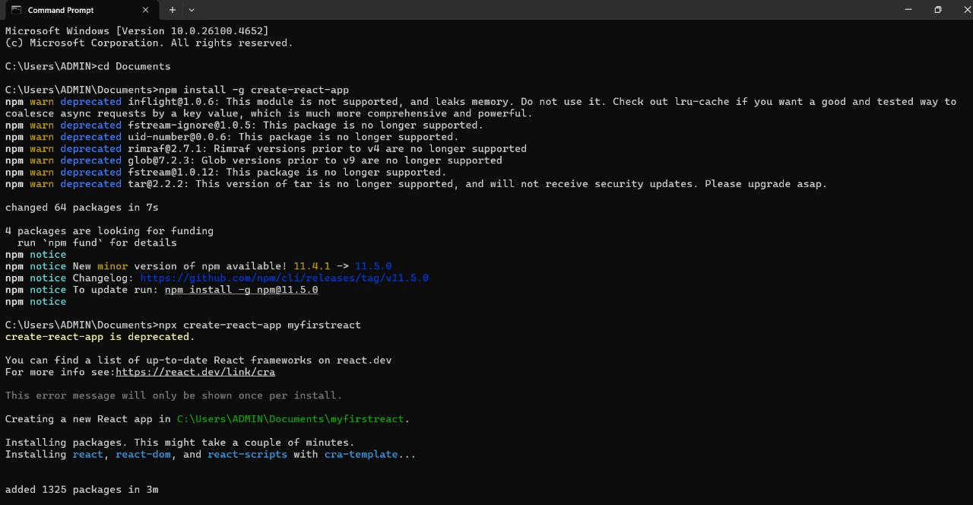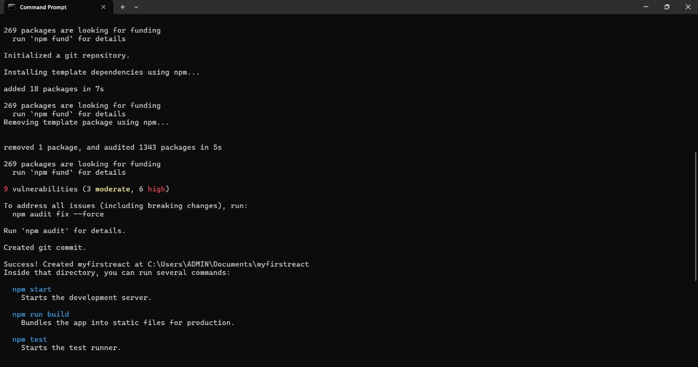

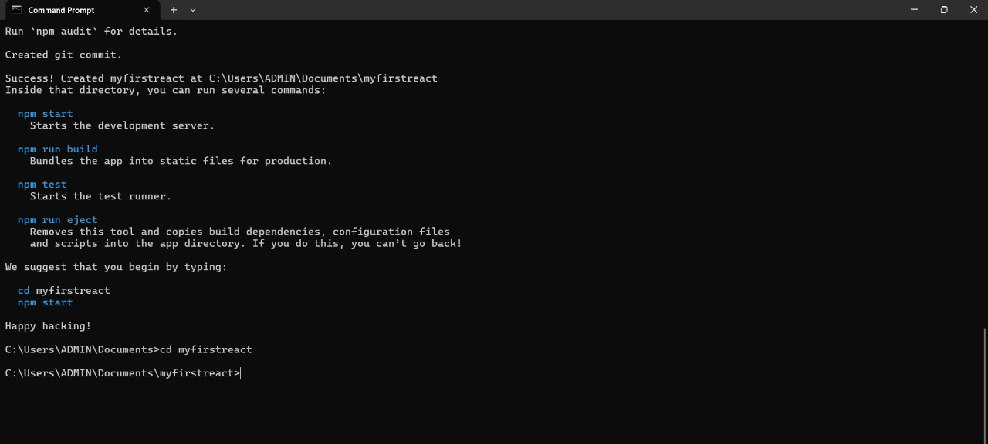

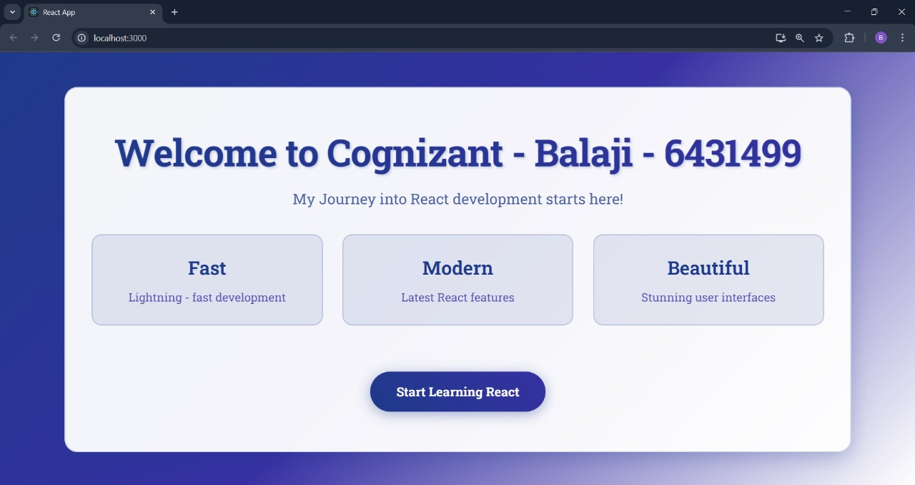

**Exercise 2: Create a react app for Student Management Portal**

**Code:**

**Home.js:**

import { Component } from 'react';

class Home extends Component{

render(){

return(

<div>

<h3>Welcome to the Home Page of Student Management Portal</h3>

</div>

);

}

}

export default Home;

**About.js:**

import { Component } from 'react';

class About extends Component{

render(){

return(

<div>

<h3>Welcome to the About Page of Student Management Portal</h3>

</div>

);

}

}

export default About;

**Contact.js:**

import { Component } from 'react';

class Contact extends Component{

render(){

return(

<div>

<h3>Welcome to the Contact Page of Student Management Portal</h3>

</div>

);

}

}

export default Contact;

**App.js:**

import './App.css';

import Home from './Components/Home';

import About from './Components/About';

import Contact from './Components/Contact';

function App(){

return (

<div className="container">

<Home/>

<About/>

<Contact/>

</div>

);

}

export default App;

**App.css:**

@import url('https://fonts.googleapis.com/css2?family=Roboto+Slab:wght@400;700&display=swap');

* {

margin: 0;

padding: 0;

box-sizing: border-box;

}

body{

font-family: 'Roboto Slab', serif;

background-color: #F8F9FA;

color: #19376D;

}

.container{

min-height: 100vh;

padding: 40px 20px;

font-family: 'Roboto Slab', serif;

max-width: 1200px;

margin: 0 auto;

}

.container::before{

content: 'Student Management Portal - Cognizant';

display: block;

text-align: center;

margin-bottom: 40px;

padding: 30px;

background-color: #19376D;

border-radius: 12px;

box-shadow: 0 4px 15px rgba(25, 55, 109, 0.3);

color: white;

font-size: 36px;

font-family: 'Roboto Slab', serif;

font-weight: bold;

text-shadow: 2px 2px 4px rgba(0, 0, 0, 0.3);

}

.container > * {

padding: 40px 20px;

text-align: center;

background-color: white;

margin: 20px 0;

border-radius: 8px;

box-shadow: 0 2px 10px rgba(25, 55, 109, 0.1);

border: 2px solid #19376D;

transition: transform 0.3s ease, box-shadow 0.3s ease;

}

.container > *:hover{

transform: translateY(-2px);

box-shadow: 0 4px 20px rgba(25, 55, 109, 0.2);

}

h3{

color: #19376D;

font-size: 28px;

font-family: 'Roboto Slab', serif;

font-weight: bold;

margin: 0;

line-height: 1.4;

}

.container::after {

content: '© 2025 Student Management Portal - Cognizant. All rights reserved.';

display: block;

text-align: center;

margin-top: 50px;

padding: 20px;

background-color: #19376D;

border-radius: 8px;

color: white;

font-size: 16px;

font-family: 'Roboto Slab', serif;

}

@media (max-width: 768px){

.container {

padding: 20px 10px;

}

.container::before{

font-size: 28px;

padding: 25px 15px;

}

h3{

font-size: 24px;

}

.container > * {

padding: 30px 15px;

margin: 15px 0;

}

}

@media (max-width: 480px){

.container::before{

font-size: 24px;

padding: 20px 10px;

}

h3{

font-size: 20px;

}

.container > * {

padding: 25px 10px;

}

}

**Output:**

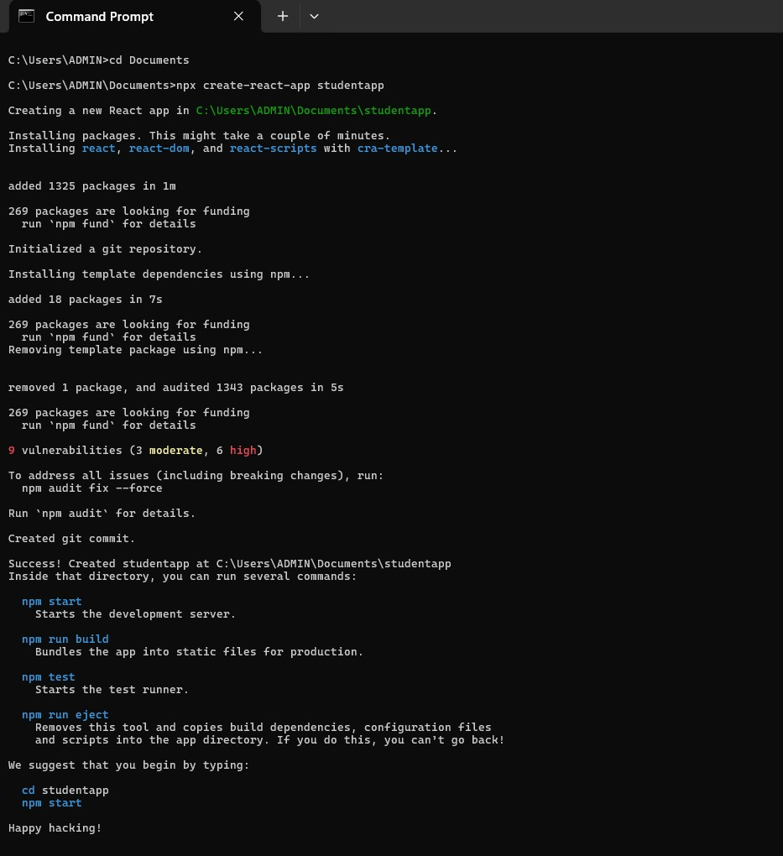

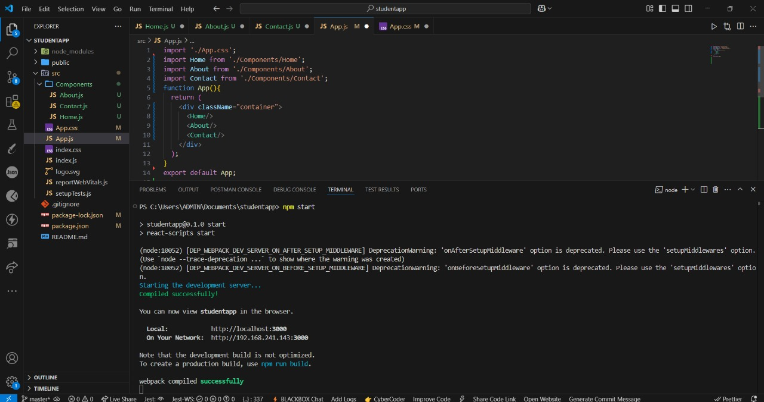

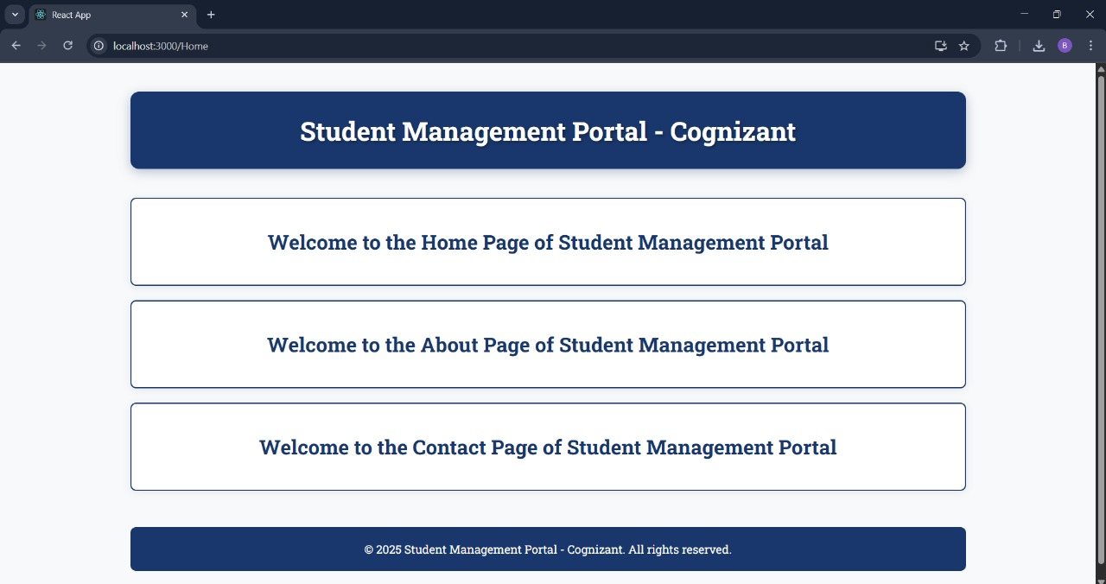

**Exercise 3 : Create a new React Application**

**Code:**

**CalculateScore.js:**

import '../Stylesheets/mystyle.css';

const percentToDecimal=(decimal)=>{

return (decimal.toFixed(2) + "%")

}

const calcScore=(total,goal)=>{

return percentToDecimal(total/goal)

}

export const CalculateScore=({Name,School,total,goal})=>(

<div className="formatstyle">

<h1 style={{color:"Brown"}}>Student Details:</h1>

<div className="Name">

<b><span>Name: </span></b>

<span>{Name}</span>

</div>

<div className="School">

<b><span>School: </span></b>

<span>{School}</span>

</div>

<div className="Total">

<b><span>Total: </span></b>

<span>{total}</span>

<span>Marks</span>

</div>

<div className="Score">

<b>Score:</b>

<span>

{calcScore(

total,

goal

)}

</span>

</div>

</div>

)

export default CalculateScore;

**mystyle.css:**

.formatstyle{

background: #ffffff;

border-radius: 15px;

padding: 40px;

box-shadow:

0 10px 30px rgba(0, 32, 96, 0.15),

0 4px 12px rgba(0, 32, 96, 0.1);

text-align: center;

font-size: 18px;

max-width: 450px;

width: 90%;

border: 2px solid #002060;

margin: auto;

}

.formatstyle h1{

color: #002060 !important;

font-size: 28px;

font-weight: 700;

margin-bottom: 25px;

font-family: 'Roboto Slab', serif;

}

.Name, .School, .Total, .Score{

margin: 15px 0;

padding: 12px 20px;

text-align: left;

font-size: 16px;

border-radius: 8px;

background: rgba(0, 32, 96, 0.02);

border-left: 4px solid;

}

.Name{

color: #1565C0;

border-left-color: #1565C0;

}

.Name b{

color: #002060;

font-weight: 600;

margin-right: 10px;

}

.School{

color: #C62828;

border-left-color: #C62828;

}

.School b{

color: #002060;

font-weight: 600;

margin-right: 10px;

}

.Total{

color: #6A1B9A;

border-left-color: #6A1B9A;

}

.Total b{

color: #002060;

font-weight: 600;

margin-right: 10px;

}

.Score{

color: #2E7D32;

border-left-color: #2E7D32;

font-size: 18px;

}

.Score b{

color: #002060;

font-weight: 600;

margin-right: 10px;

}

.Score span:last-child{

color: #2E7D32;

font-weight: 700;

font-size: 20px;

}

@media (max-width: 600px){

.formatstyle{

padding: 25px;

font-size: 16px;

max-width: 350px;

}.formatstyle h1{

font-size: 24px;

margin-bottom: 20px;

}

}

**App.css:**

@import url('https://fonts.googleapis.com/css2?family=Roboto+Slab:wght@300;400;500;600;700;800;900&display=swap');

*{

margin: 0;

padding: 0;

box-sizing: border-box;

}

body{

font-family: 'Roboto Slab', serif;

background: linear-gradient(135deg, #ffffff 0%, #f8f9fa 50%, #e3f2fd 100%);

min-height: 100vh;

display: flex;

align-items: center;

justify-content: center;

}

#root{

width: 100%;

display: flex;

justify-content: center;

align-items: center;

min-height: 100vh;

}

.App{

text-align: center;

width: 100%;

}

**App.js:**

import './App.css';

import {CalculateScore} from './Components/CalculateScore';

function App(){

return(

<div className="App">

<CalculateScore

Name={"Balaji V - 6431499"}

School={"Cognizant Technology Solutions"}

total={284}

goal={3}

/>

</div>

);

}

export default App;

**Output:**

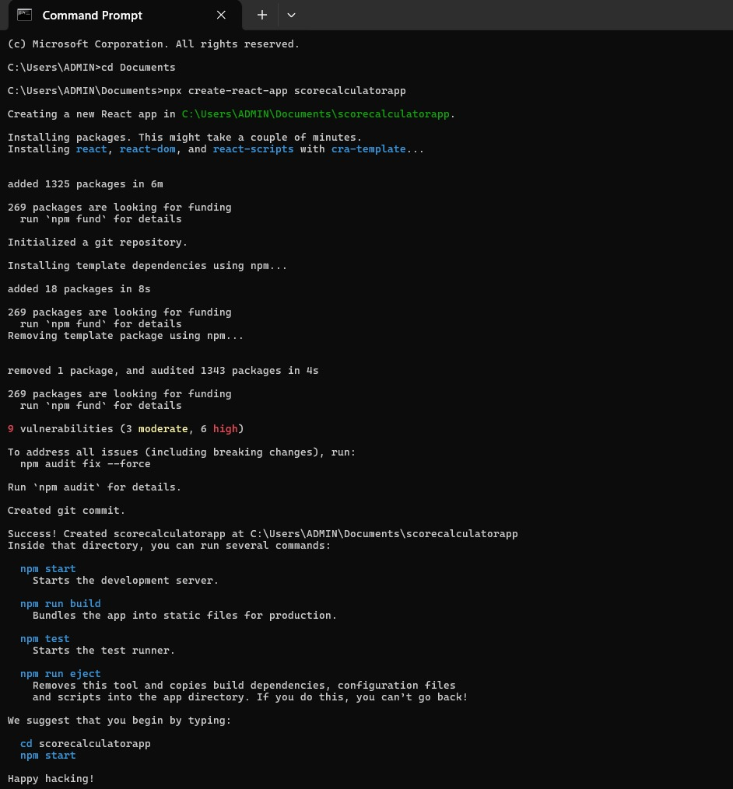

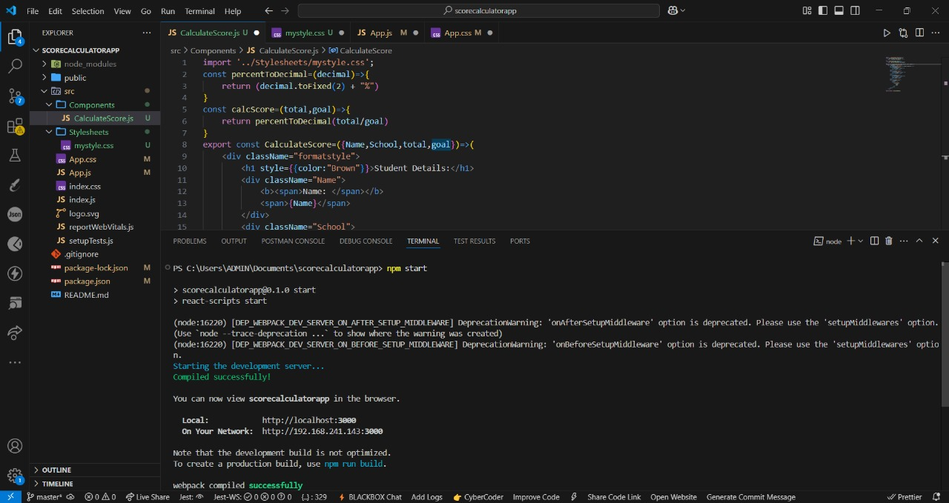

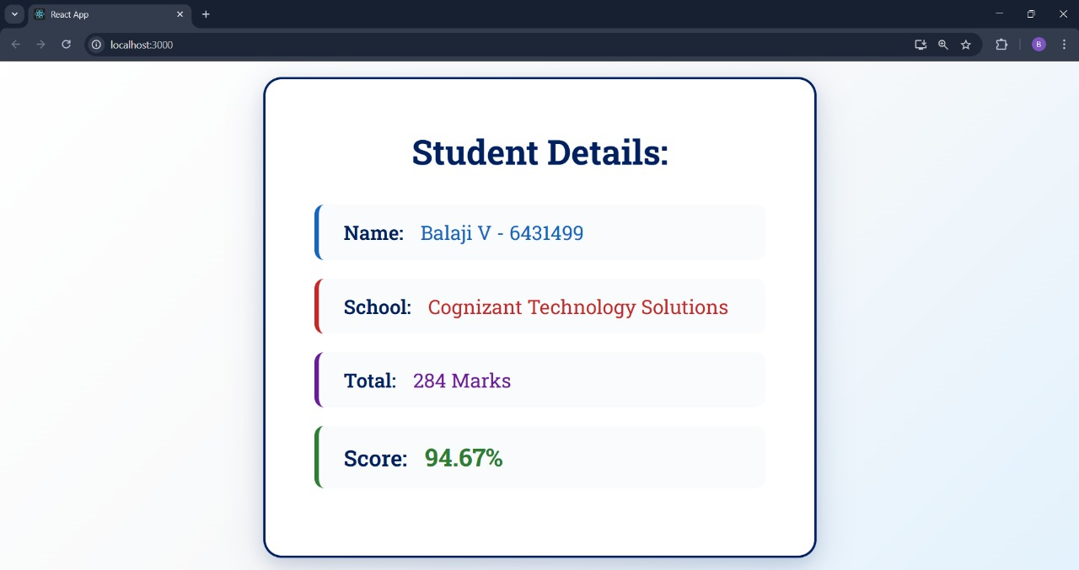

**Exercise 4 : React Application – Blog App**

**Code:**

**Post.js:**  
class Post{

constructor(id,title,body){

this.id=id;

this.title=title;

this.body=body;

}

}

export default Post;

**Posts.js:**

import React from "react";

import Post from "./Post";

import "./Posts.css";

class Posts extends React.Component{

constructor(props){

super(props);

this.state={

posts: [],

};

}

loadPosts(){

fetch("https://jsonplaceholder.typicode.com/posts")

.then((res) => res.json())

.then((data) => {

const posts=data.map(

(item) => new Post(item.id, item.title, item.body)

);

this.setState({ posts });

})

.catch((err) => {

alert("Error fetching posts: " + err.message);

});

}

componentDidMount(){

this.loadPosts();

}

componentDidCatch(error, info){

alert("An error occurred in Posts component.");

console.error("Error info:", info);

}

render(){

return(

<div className="container">

<h1 className="header">Welcome to Cognizant Blogs</h1>

<div className="posts-grid">

{this.state.posts.map((post)=>(

<div key={post.id} className="post-card">

<h2>{post.title}</h2>

<p>{post.body}</p>

</div>

))}

</div>

</div>

);

}

}

export default Posts;

**Posts.css**

body{

margin: 0;

font-family: 'Roboto Slab', serif;

background-color: #ffffff;

color: #0a192f;

transition: all 0.3s ease;

}

.container{

max-width: 1500px;

margin: 40px auto;

padding: 0 20px;

}

.header{

font-size: 2.5rem;

text-align: center;

color: #0a192f;

margin-bottom: 40px;

position: relative;

}

.header::after{

content: "";

display: block;

width: px;

height: 3px;

background: #0a192f;

margin: 12px auto 0;

border-radius: 10px;

}

.posts-grid{

display: grid;

grid-template-columns: repeat(auto-fit, minmax(300px, 1fr));

gap: 25px;

}

.post-card{

background: linear-gradient(145deg, #0c1e35, #09162a);

border-radius: 15px;

padding: 25px;

box-shadow: 8px 8px 16px rgba(10, 25, 47, 0.2), -8px -8px 16px rgba(10, 25, 47, 0.2);

transition: transform 0.3s ease, box-shadow 0.3s ease;

border: 1px solid rgba(255, 255, 255, 0.05);

color: #ffffff;

}

.post-card:hover{

transform: translateY(-5px);

box-shadow: 12px 12px 24px rgba(10, 25, 47, 0.3), -12px -12px 24px rgba(10, 25, 47, 0.3);

}

.post-card h2{

font-size: 1.4rem;

color: #64ffda;

margin-bottom: 10px;

}

.post-card p{

color: #ccd6f6;

line-height: 1.7;

font-size: 1rem;

}

**App.js:**

import Posts from "./Posts";

function App(){

return(

<div className="App">

<Posts/>

</div>

);

}

export default App;

**App.css:**

.App{

min-height: 100vh;

padding: 20px;

background-color: #ffffff;

}

.app-header{

text-align: center;

margin-bottom: 40px;

padding: 20px;

}

.app-title{

font-family: 'Roboto Slab', serif;

font-size: 3rem;

font-weight: 700;

color: #0a192f;

text-shadow: 1px 1px 2px rgba(0, 0, 0, 0.05);

margin-bottom: 10px;

}

.app-subtitle{

font-family: 'Roboto Slab', serif;

font-size: 1.2rem;

font-weight: 300;

color: #444444;

opacity: 0.8;

}

.loading{

text-align: center;

font-size: 1.5rem;

color: #0a192f;

margin-top: 50px;

}

.error-message{

background: rgba(255, 107, 107, 0.1);

border: 2px solid #ff6b6b;

border-radius: 10px;

padding: 20px;

margin: 20px auto;

max-width: 600px;

text-align: center;

color: #b00020;

font-family: 'Roboto Slab', serif;

}

**index.css:**

@import url('https://fonts.googleapis.com/css2?family=Roboto+Slab:wght@300;400;500;600;700&display=swap');

*{

margin: 0;

padding: 0;

box-sizing: border-box;

}

body {

font-family: 'Roboto Slab', serif;

background: linear-gradient(135deg, #e6ecf5 0%, #dbe9f6 50%, #cddfee 100%);

min-height: 100vh;

color: #ffffff;

}

#root {

min-height: 100vh;

}

**Output:**

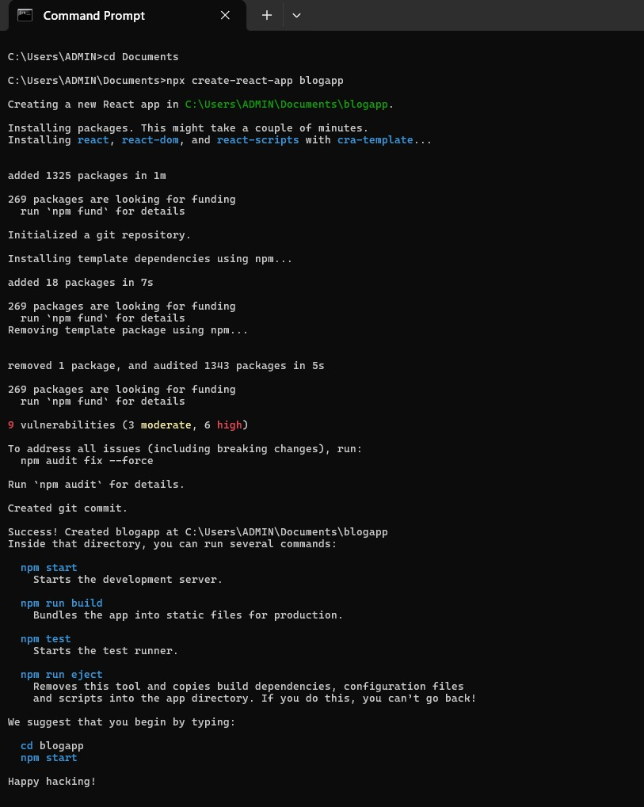

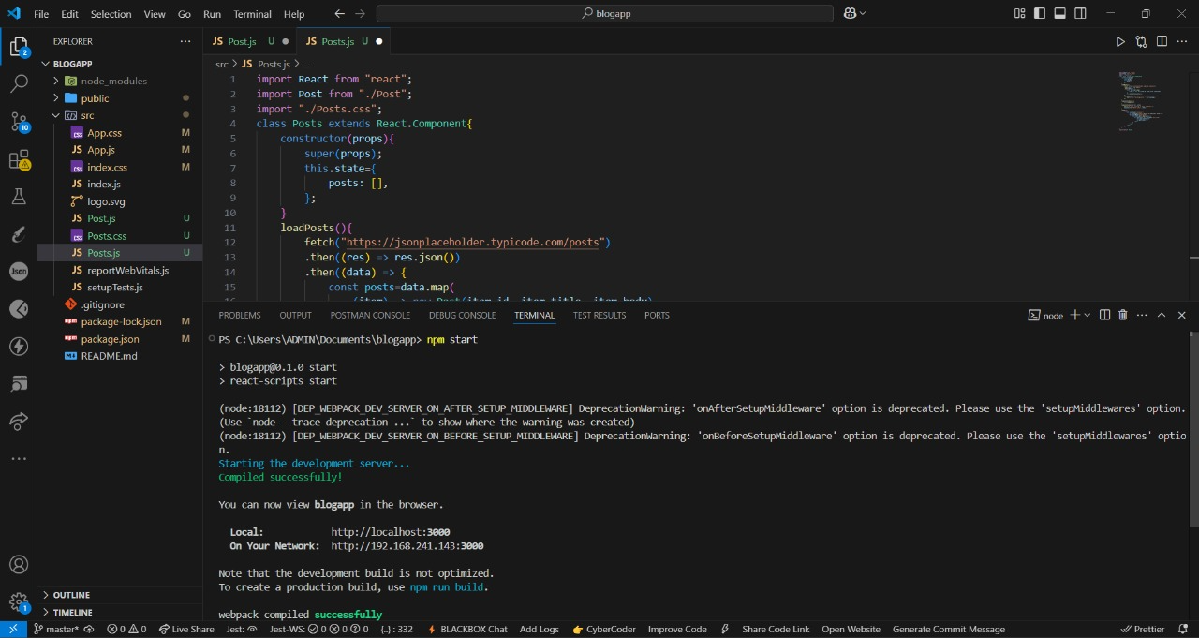

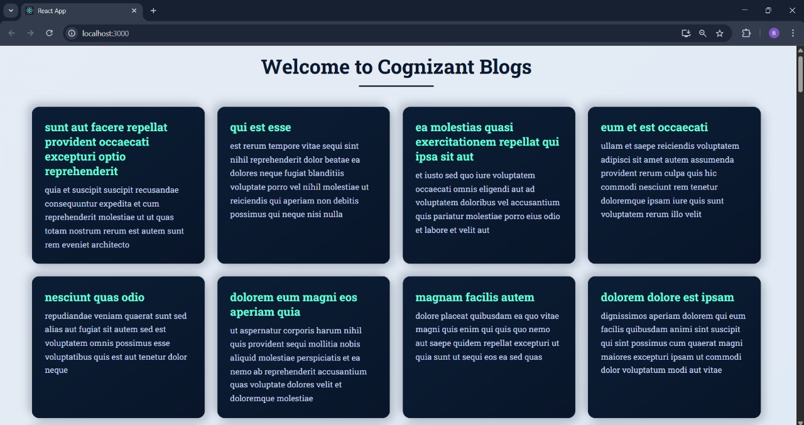

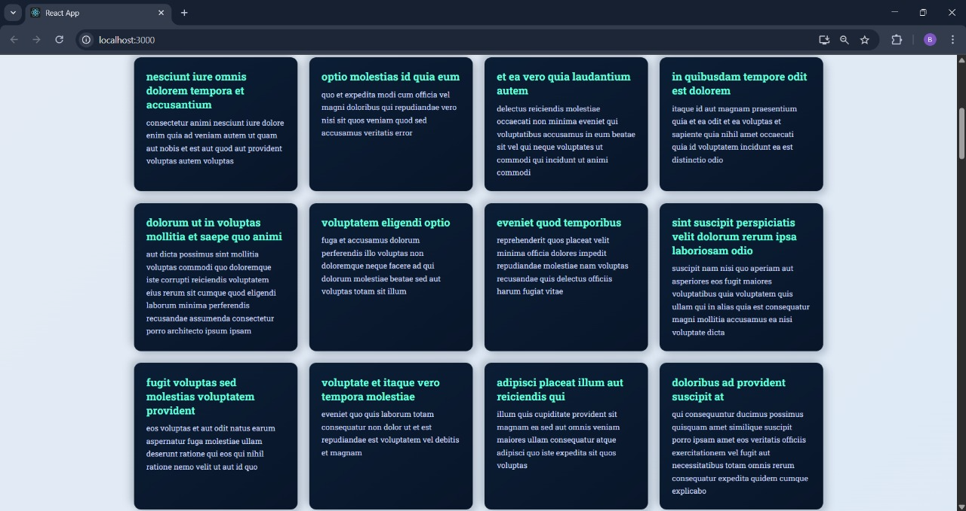

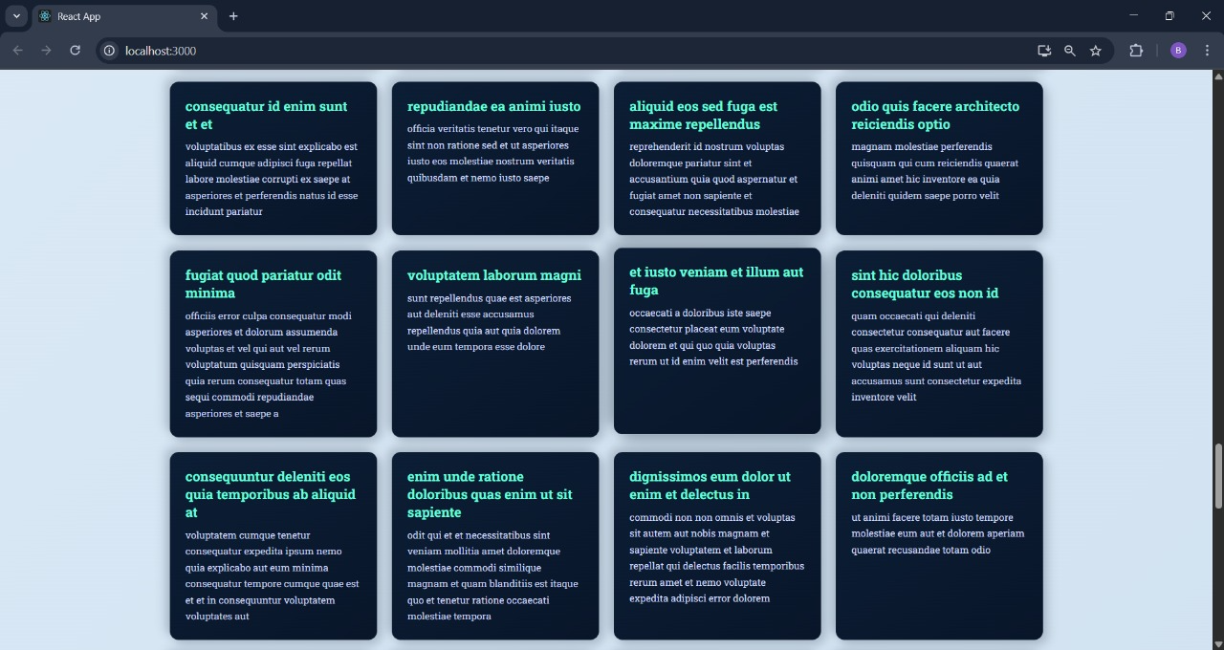

**Exercise 5:**

**Code:**

**App.js:**

import CohortDetails from './CohortDetails';

const cohortData=[

{

name: "INTADMDF10 - .NET FSD",

startDate: "25-Jul-2025",

status: "Scheduled",

coach: "Aathma",

trainer: "Jojo Jose"

},

{

name: "ADM21JF014 - Java FSD",

startDate: "25-Mar-2025",

status: "Ongoing",

coach: "Apoorv",

trainer: "Elisa Smith"

},

{

name: "CDBJF21025 - Java FSD",

startDate: "24-Dec-2024",

status: "Ongoing",

coach: "Aathma",

trainer: "John Doe"

}

];

function App(){

return(

<div>

<CohortDetails cohorts={cohortData}/>

</div>

);

}

export default App;

**CohortDetails.js:**

import styles from './CohortDetails.module.css';

const CohortDetails=({ cohorts })=>{

return(

<div>

<h2>Cohorts Details</h2>

{cohorts.map((cohort, index)=>{

const statusColor=cohort.status.toLowerCase() === 'ongoing' ? 'green' : 'blue';

return(

<div key={index} className={styles.box}>

<h3 style={{ color: statusColor }}>{cohort.name}</h3>

<dl>

<dt>Started On</dt>

<dd>{cohort.startDate}</dd>

<dt>Current Status</dt>

<dd>{cohort.status}</dd>

<dt>Coach</dt>

<dd>{cohort.coach}</dd>

<dt>Trainer</dt>

<dd>{cohort.trainer}</dd>

</dl>

</div>

);

})}

</div>

);

};

export default CohortDetails;

**CohortDetails.module.css:**

.box{

width: 300px;

display: inline-block;

margin: 10px;

padding: 10px 20px;

border: 1px solid black;

border-radius: 10px;

}

dt{

font-weight: 500;

}

**Output:**

